**Role of kinases MAP2K1/MEK1, PDHK and NEK1 on Hedgehog Signaling Activation**

**Paige Halas**

**Graduate Program in Cellular & Molecular Biosciences**

**University of California, Irvine**

**Fall 2019 Rotation Report**

This report was written by the student, has a distinct and reachable goal, and represents a reasonable amount of work for one rotation project earning 4 units of academic credit. The student will learn new techniques and approaches consistent with the goals of the rotation program.

Rotation Supervisor’s Name: Dr. Scott Atwood

 Signed_____________________________________  Date __________

Faculty Advisor’s Name: Dr. Eric Pearlman

Signed_____________________________________  Date __________

**Introduction**

Basal Cell Carcinoma (BCC) is the most abundant skin cancer in the United States with 4 million diagnoses per year 1. Additionally, there is a high rate of reoccurrence of BCC despite successful treatment 1.This cancer is caused by uncontrolled activation of the Hedgehog (Hh) Signaling Pathway. The Hedgehog Signaling Pathway becomes active when a Hedgehog Signaling ligand binds to the Patched (PTCH) receptor on the primary cilia of a cell, thus activating the signal transducer Smoothened (SMO). SMO then moves to the cilium where it binds and inhibits Suppressor of Fused (SUFU), resulting in transcription factor activation of Glioma-Associated Oncogene (GLI) 2. Mutations that occur in regulators of the Hh Signaling Pathway such as PTCH1, SMO and GLI cause uncontrolled activation of the Hh pathway leading to the development of BCC 3. To treat BCC, small molecule drugs that inhibit SMO, such as Vismodegib, have been used to modulate the Hedgehog Signaling pathway by preventing the release of GLI transcription factors. The high reoccurrence rate of this cancer is due to two phenomena. BCC tumors can acquire resistance to SMO inhibitors, thus causing a loss of the GLI inhibitor SUFU and the increase of transcription factors in the system 4,5. Additionally, mutations in SMO have caused the drug to be ineffective in suppressing its target and thus allowing Hedgehog Signaling to be active despite the presence of a SMO inhibitor 5. BCC resistance to SMO inhibitors and mutations in SMO have directed attention to GLI transcription factors downstream of SMO as targets for BCC treatment. Our lab has compiled a list of recurrent mutations of GLI1 and GLI2, which activate Hedgehog Signaling, from the COSMIC database and screened the mutations for their ability to activate the pathway. In analyzing these Hedgehog activating re-current mutations, the mutation sites were found to be phosphosites. A mechanism of regulation of GLI proteins into transcriptional activators through multi-site phosphorylation could be through the activity of protein kinases 6. The purpose of this project is to assess the role of kinases predicted to be active at recurrent GLI mutation sites on the Hedgehog Signaling Pathway.

Mitogen-Activated Protein Kinase 2 (MAP2K1/MEK1) is active at re-current GLI mutations sites determined experimentally to activate Hh Signaling. Mutations in MAP2K1/MEK1 are correlated with melanoma and inhibiting this kinase reduces metastasis in pancreatic cancer 7–9. Additionally, MAP2K1/MEK1 stabilizes GLI and activates Hedgehog Signaling 9. Cobimetinib is effective as a MAP2K1/MEK1 inhibitor and is used to treat melanoma with an IC50 of 4.2 nM 10. Pyruvate Dehydrogenase Kinase (PDHK) regulates glycolysis which is more highly active in cancer cells than normal cells 11. A PDHK inhibitor, Dichloroacetic acid (IC50, 81.03 mM), upregulates apoptosis of ovarian cancer cells 12. The prediction of PDHK activity on re-current GLI mutation sites, makes it of interest in assessing its inhibition in Basal Cell Carcinoma. NIMA Related Kinase (NEK1) affects Hh signaling through its role regulating primary cilia development and has demonstrated activity in cancer 13,14. Zinc05007751 is a highly selective NEK1 inhibitor with an IC50 of 3.4 μM. As MAP2K1/MEK1, PDHK and NEK1 kinases are predicted to be active at recurrent mutation sites in GLI, their inhibition is predicted to influence transcriptional activity and activate Hedgehog Signaling.

**Hypothesis**

We hypothesize that MAP2K1/MEK1, PDHK and NEK1 kinases which have been predicted to phosphorylate recurrent GLI mutation sites will cause activation of Hedgehog Signaling.

**Materials and Methods**

**Kinase Prediction**

A compilation of GLI1 and GLI2 mutations that occur three or more times in cancer cells in the Catalogue of Somatic Mutations in Cancer (COSMIC) database have been generated and previously screened for their Hedgehog Signaling activation in the Atwood Lab. It was found that these mutation sites are phosphosites which can be influenced by kinase activity. In this project, kinases which are predicted to be active within four residues of a recurring mutation site using Group-Based Prediction Software (GPS) and PhosphoNet Kinase Predictor are compiled. Kinase candidates having previous evidence of mediating phosphorylation and activating Hedgehog Signaling at a particular mutation site were eliminated from the compilation. Previous insight into their activity in cancer or cilia development as well as inhibitor accessibility drove the selection of MAP2K1/MEK1, PDHK and NEK1 to experimentally evaluate Hedgehog Signaling effects due to kinase activity.

**Cell Dosing, RNA Extraction, RT-qPCR**

Cobimetinib, Dichloroacetic Acid, and Zinc05007751 are selected as inhibitors for MAP2K1/MEK1, PDHK and NEK1 respectively due to their availability, specificity and IC50 range. To promote the generation of primary cilia and Hedgehog Pathway activation, Wild Type (3T3) cells are serum starved and serum starved with Hedgehog conditioned media immediately before treatment with these inhibitors. Inhibitors are added at their IC50s and serially increased on a logarithmic scale to three higher concentrations. Similarly, Basal Cell Carcinoma Cells are serum starved and treated with inhibitors as in Wild Type cells. These cell types and serum conditions are all treated with diluent only (DMSO) as a control. After 24 hours of incubation, RNA is extracted and quantified from both diluent and drug treated cells using the Zymo Research Direct-Zol RNA Miniprep Plus kit. Extracted RNA is amplified using RT-qPCR with primers specific for the GLI1 gene as a means of quantifying Hedgehog Signaling activation, as well as a GAPDH experimental control to quantify GLI expression. Fold change was normalized to the diluent only (DMSO) control in Serum Starved media (SS) for each cell line (3T3 and BCC). Standard error bars denote technical replicates between drug treated samples.

**Metabolic Activity (MTT) Assay**

To confirm that kinase inhibitors would not cause cell death *in vivo*, an MTT Assay is conducted on diluent (DMSO) and drug treated BCC cells. Cells are seeded at 2,000 cells/well and grown to 50% confluence. Once desired confluence is achieved, kinase inhibitors (Cobimetinib, Dichloroacetic Acid, and Zinc05007751) are added at their IC50 and three logarithmically increased concentrations, as in qPCR treatment, to the cells in replicates of six. When performing the assay, MTT reagent in PBS is added to the each well and allowed to incubate at 36°C for two hours protected from light. After incubation, the MTT reagent is removed and MTT solvent (DMSO) is added to the wells and allowed to shake. Cell proliferation is quantified by measuring the absorbance at 570 nm for BCC cells at 0, 2, 4 and 6 days post drug addition.

**Results**

**Inhibition of MAP2K1/MEK1 does not impact activation of Hedgehog Signaling**

Previous evidence of the role of MAP2K1/MEK1 in cancer and its ability to activate Hedgehog Signaling proposed the hypothesis that inhibiting this kinase with Cobimetinib would decrease Hedgehog Signaling activity. GLI1 expression, indicative of Hedgehog Signaling, is not affected in the presence of MAP2K1/MEK1 Cobimetinib kinase inhibitor at the concentrations tested (**Figure 1**). Increased expression of GLI1 is observed for Wild Type (3T3) cells under serum starved with Hedgehog conditioned media (HH SS) in comparison to serum starved media. However, fold change does not vary between Cobimetinib concentrations of SS or HH SS treated 3T3 cells (**Figure 1A**). This observation is consistent in the Basal Cell Carcinoma (BCC) cell line with the exception of the 100 nM concentration of Cobimetinib (**Figure 1B**).

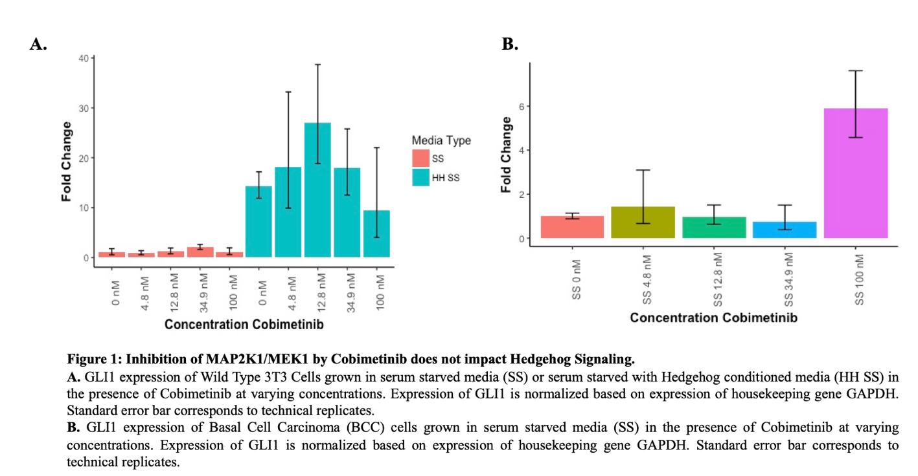

In assessing the cell viability in the BCC cell line, as the concentration of Cobimetinib increases, the cell death with Cobimetinib drug treatment is consistent over a period of 6 days with the exception of the highest concentration 100 nM (**Figure 2**).

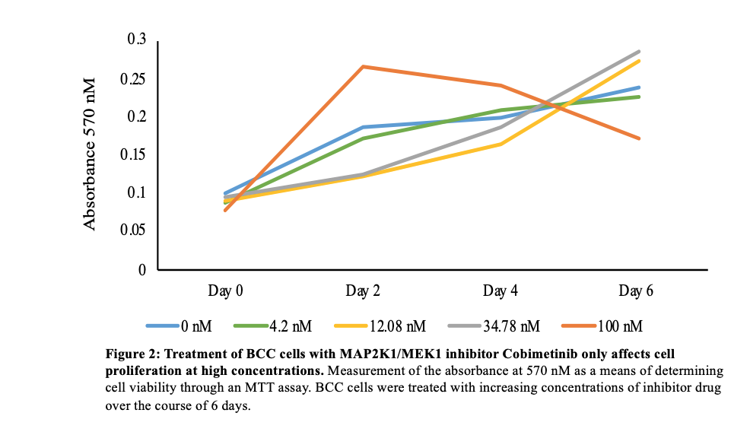

**Hedgehog Signaling activity is not impacted by PDHK Inhibition with Dichloroacetic Acid**

Increased activity of PDHK in cancer cells suggests that its inhibition with Dichloroacetic acid could reduce Hedgehog Signaling. Hedgehog Signaling activity measured through GLI1 expression is not affected in the presence of Dichloroacetic acid at the concentrations tested (**Figure 3**). The fold change of GLI in the HH SS Wild Type cells is higher than in the SS Wild Type cells. Between concentrations of Dichloroacetic Acid, GLI expression levels are within the standard deviation in the SS condition. In the case of the HH SS treated Wild Type cells, GLI expression is only lower at the IC50 of 80 nM Dichloroacetic Acid (**Figure 3A**). In BCC cells treated with Serum Starved (SS) Media, GLI1 expression is within the standard error bars for all concentrations of inhibitor (**Figure 3B**).

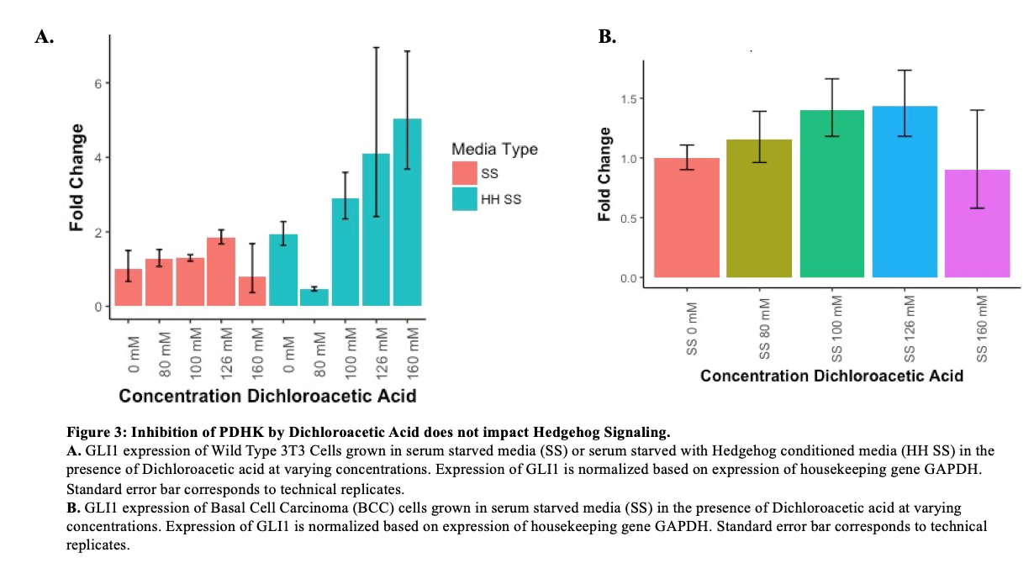

To assess *in vivo* toxicity of the drug, an MTT assay was conducted where absorbance is consistent for all concentrations of PDHK inhibitor over a period of 6 days. (**Figure 4**).

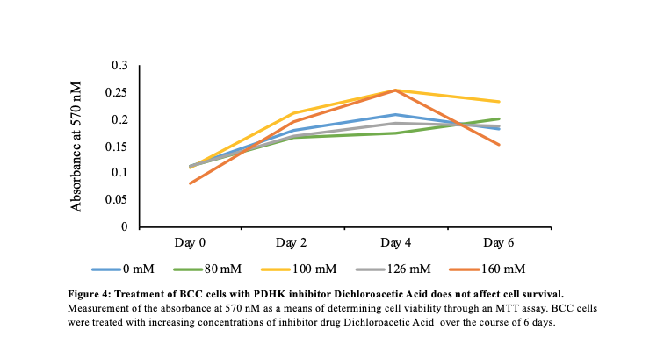

**NEK1 Inhibition Demonstrates Reduction of Hedgehog Signaling Activity**

The effect of NEK1 on the regulation of cilia development and its correlation in cancer suggests inhibition of NEK1 with Zinc05007751 affects activation of Hedgehog Signaling. The fold change of GLI in diluent only Wild Type samples increased in the HH SS media condition versus the SS media (**Figure 5**). However, in the HH SS samples, GLI expression decreased beyond the error bars with drug treatment as low as at the IC50 of 3.4 μM (**Figure 5A**). Additionally, there is a decrease in fold change with drug treatment in the BCC cell line (**Figure 5B**). The addition of this drug does not influence cell death in an *in vivo* setting which confirms that the decrease in GLI expression with drug addition is not due to decrease in cell viability (**Figure 6**).

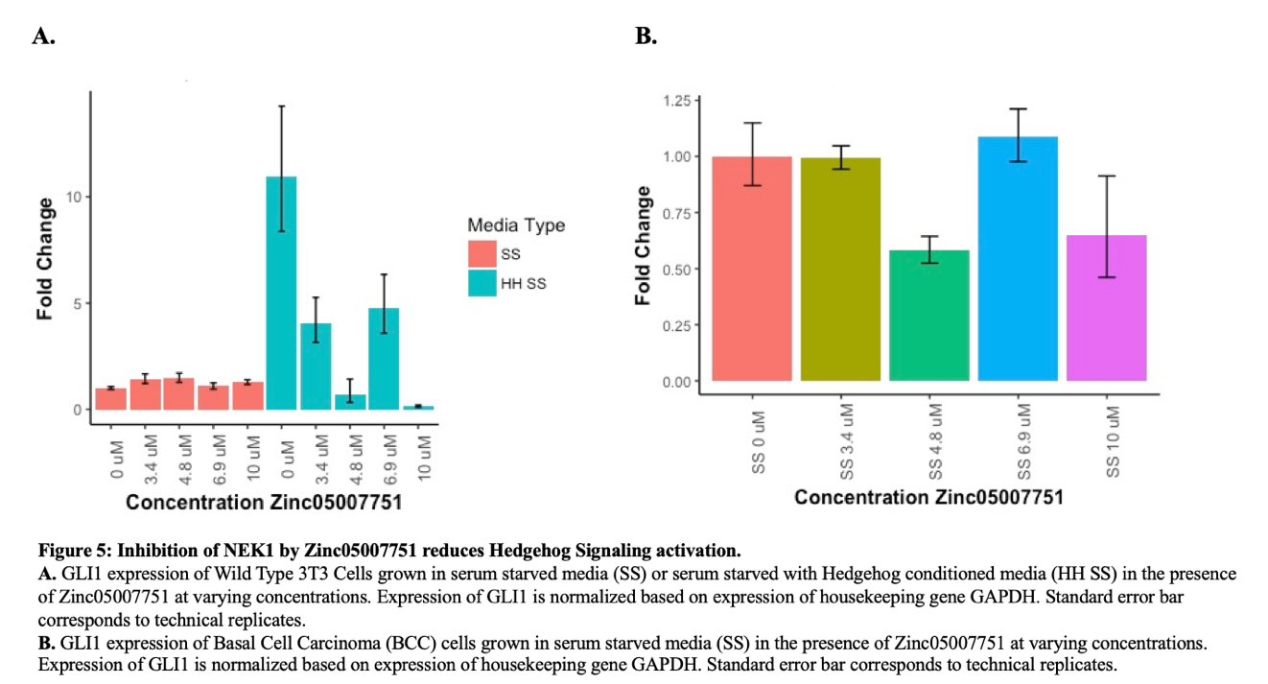

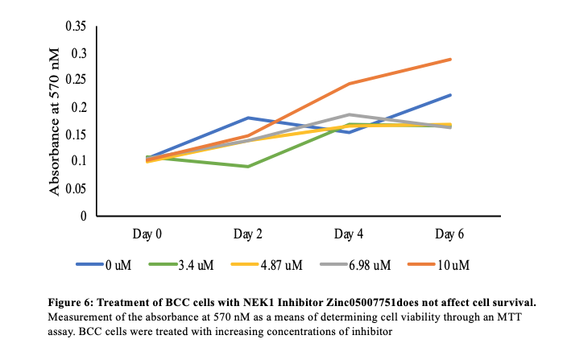

**Discussion**

MAP2K1/MEK1, PDHK and NEK1, which are predicted to be present at recurrent mutation sites were expected to activate Hedgehog Signaling. Although Cobimetinib and Dichloroacetic Acid do not contribute to cell death, MAP2K1/MEK1 and PDHK do not demonstrate significant activation of Hedgehog Signaling in Wild Type and BCC cells treated with inhibitor as compared to diluent only treated cells. Using the Cobimetinib inhibitor of MAP2K1/MEK1 which is currently used as treatment for melanoma, there is no activation of Hedgehog Signaling by MAP2K1/MEK1 (**Figures 1, 2**). The dramatic increase in fold change with 100 nM Cobimetinib treatment in the BCC cell line would likely be reduced with an experimental replicate. However, it could be that this response is indicative of a bimodal distribution where the effect on the pathway is different at low versus higher concentrations. Lack of activation of Hedgehog Signaling with inhibition of MAP2K1/MEK1 suggests this kinase is not worth further pursuit. Dichloroacetic Acid, a PDHK inhibitor selected for its accessibility, did not impact activation of Hedgehog Signaling (**Figure 3**). Increasing the range of drug dosage may better inhibit PDHK and thus demonstrate reduction of GLI mRNA in the presence of inhibitor. However, as this inhibitor is a general acid, it is likely interacting with multiple pathways within the cell; therefore, it would be critical to knock down the PDHK kinase with a short hairpin RNA or CRISPR to determine that the acid is acting on the anticipated target kinase. MAP2K1/MEK1 and PDHK, although predicted at recurrent activating mutation sites, do not activate the Hedgehog Signaling Pathway as expected.

NEK1, which is responsible for regulating cilia development, activates Hedgehog Signaling through the assay tested without impacting cell death (**Figures 5, 6**). Assessing GLI expression in diluent only treated Wild Type serum starved and Wild Type serum starved cells with Hedgehog conditioned media, we see increased expression of GLI mRNA in the Hedgehog conditioned media. This result is anticipated as the pathway is upregulated in these culturing conditions. When the Wild Type cells in Hedgehog conditioned serum starved media are treated with concentrations of NEK1 inhibitor Zinc05007751, GLI expression dramatically decreases. This decrease in fold change demonstrates the role of NEK1 in activating Hedgehog Signaling. This result is consistent in the serum starved BCC cells where Hedgehog Signaling is activated.

As NEK1 demonstrated expected activation of Hedgehog Signaling, it is of interest to confirm the role of NEK1 as a Hedgehog activator. To gain more significant GLI reduction with inhibitor, it would be essential to incubate the Wild Type and BCC cells with their respective serum starved conditions for 24 hours before treatment to allow for the development of primary cilia. Additionally, it would be of interest to increase the Zinc05007751 treatment concentration range to gain a greater understanding of the activation of Hedgehog Signaling with the inhibition of NEK1. As the MTT assay was run on a BCC cell line that has developed resistance over time, the cell cytotoxicity assay would need to be validated in a mouse keratinocyte line to better mimic toxicity in an organism. Finally, it would be interest to validate NEK1 as the target of Zinc05007751 by knocking out the kinase with short hairpin RNA or CRISPR.

After confirming the role of NEK1 in activating Hedgehog Signaling, the mechanism by which GLI1 and NEK1 interact would need to be investigated. To determine if GLI1 and NEK1 interact directly, an *in vitro* assay with recombinant GLI and NEK1 proteins would be conducted. Additionally, a co-immunoprecipitation assay can be used to assess the interaction of these two proteins *in vivo* with antibody conjugates. Concurrent to these experiments, a larger kinase screen using the methodology used in this project would need to be conducted on other kinases candidates predicted to be active at re-current GLI1 mutation sites such as BUB1, PAK6 and CDK19 to expand the search of kinases that activate Hedgehog Signaling. From this rotation project we can conclude that NEK1 kinase plays a role in activating the Hedgehog Signaling pathway.

**Works Cited**

1. Basal Cell Carcinoma. *The Skin Cancer Foundation* https://www.skincancer.org/skin-cancer-information/basal-cell-carcinoma/.

2. Varjosalo, M. & Taipale, J. Hedgehog signaling. *J. Cell Sci.* **120**, 3–6 (2007).

3. Atwood, S. X., Chang, A. L. S. & Oro, A. E. Hedgehog pathway inhibition and the race against tumor evolution. *J. Cell Biol.* **199**, 193–197 (2012).

4. Pricl, S. *et al.* Smoothened (SMO) receptor mutations dictate resistance to vismodegib in basal cell carcinoma. *Mol. Oncol.* **9**, 389–397 (2015).

5. Sharpe, H. J. *et al.* Genomic analysis of Smoothened inhibitor resistance in basal cell carcinoma. *Cancer Cell* **27**, 327–341 (2015).

6. Niewiadomski, P. *et al.* Gli protein activity is controlled by multi-site phosphorylation in vertebrate Hedgehog signaling. *Cell Rep.* **6**, 168–181 (2014).

7. Gu, D. *et al.* Simultaneous Inhibition of MEK and Hh Signaling Reduces Pancreatic Cancer Metastasis. *Cancers* **10**, (2018).

8. Liu, Z., Li, T., Reinhold, M. I. & Naski, M. C. MEK1-RSK2 contributes to Hedgehog signaling by stabilizing GLI2 transcription factor and inhibiting ubiquitination. *Oncogene* **33**, 65–73 (2014).

9. Liu, H. *et al.* The MEK/ERK signalling cascade is required for sonic hedgehog signalling pathway-mediated enhancement of proliferation and inhibition of apoptosis in normal keratinocytes. *Exp. Dermatol.* **23**, 896–901 (2014).

10. Rowdo, F. P. M., Barón, A., Von Euw, E. M. & Mordoh, J. In vitro long-term treatment with MAPK inhibitors induces melanoma cells with resistance plasticity to inhibitors while retaining sensitivity to CD8 T cells. *Oncol. Rep.* **37**, 1367–1378 (2017).

11. Golias, T., Kery, M., Radenkovic, S. & Papandreou, I. Microenvironmental control of glucose metabolism in tumors by regulation of pyruvate dehydrogenase. *Int. J. Cancer* **144**, 674–686 (2019).

12. Zhou, L. *et al.* <p>Dichloroacetic acid upregulates apoptosis of ovarian cancer cells by regulating mitochondrial function</p>. *OncoTargets and Therapy* https://www.dovepress.com/dichloroacetic-acid-upregulates-apoptosis-of-ovarian-cancer-cells-by-r-peer-reviewed-fulltext-article-OTT (2019) doi:10.2147/OTT.S194329.

13. Melo-Hanchuk, T. D. *et al.* NEK1 kinase domain structure and its dynamic protein interactome after exposure to Cisplatin. *Sci. Rep.* **7**, (2017).

14. Evangelista, M. *et al.* Kinome siRNA Screen Identifies Regulators of Ciliogenesis and Hedgehog Signal Transduction. *Sci. Signal.* **1**, ra7–ra7 (2008).